Four Ways to More Powerful Searches in Google Scholar and Search It
 | Google Scholar | Search It
- Search for a Phrase  Systems will retrieve items that contain the typed words unless deliberately enclosed in quotation marks to designate a phrase. | Use quotations marks  “global warming” | Use quotation marks  “global warming”
- Boolean Search Terms  Grouping Terms with a Query  These terms work like shorthand for the system to treat the typed words accordingly. | + (AND) , OR, -  ( )  "student writing" + (assessment OR evaluation) -ESL –EFL  Note: + or AND will create equal results and can be used interchangeably. | AND, OR, NOT  ( )  “student writing” AND assessment NOT (ESL OR EFL)
- Use Wildcard Characters | *  Used as a stand-in for 1 or more words:  culture * women for culture affects every women  cultural view of women  ?  Zero or several characters  saccharide? for saccharide  hepta-saccharide  saccharide-binding  Note: Wildcards work at the beginning of a word! | *  Multiple characters:  culture* for cultures, cultural, culturally  ?  One character:  wom?n for woman, women  Note: Wildcards never work at the beginning of a word!
- Select Search Scope  Some systems define a search scope dependent on log-on that must be manipulated to focus on peer-reviewed articles or Summit borrowing. | Automatic | Use the drop-down list

Google Scholar users, please remember to configure your laptops in order to take advantage of the Libraries’ substantial content. Go into Settings and click on “library links” from the left-hand sidebar. Type ”Washington State University Libraries” into the box to reveal the “Find It@ WSU Libraries” option.
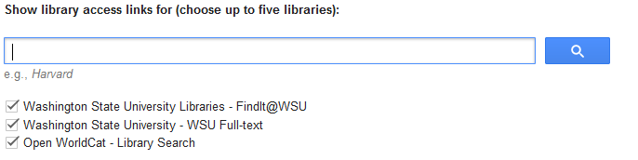 Christy Zlatos zlatos@wsu.edu 8/31/2017

