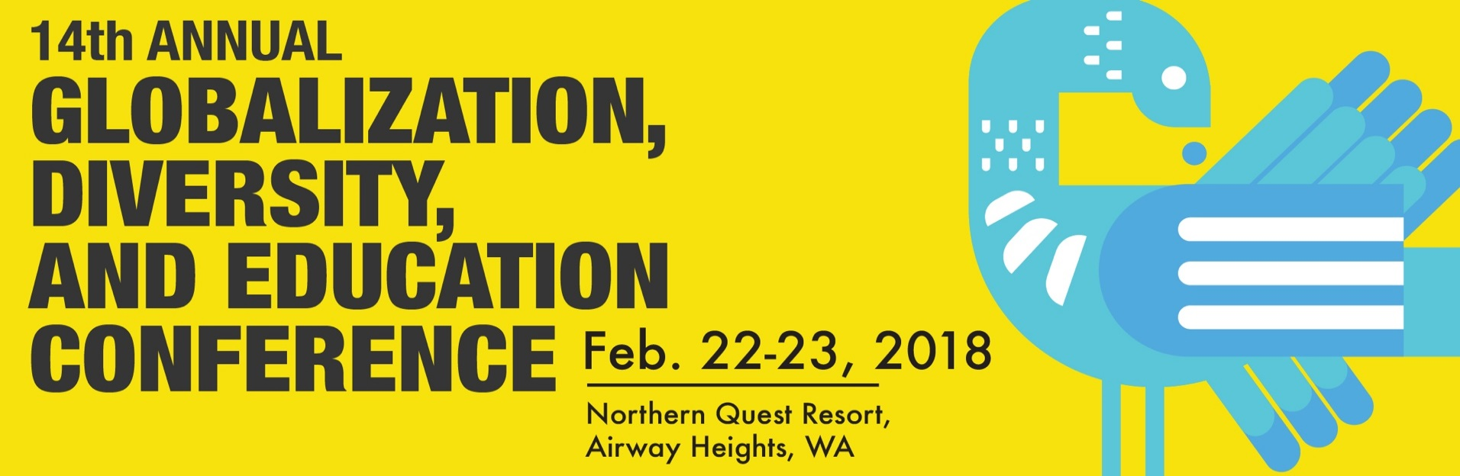

Call For:

Papers, Panels, Workshops, and Posters

Theme: Power and Cultural Politics in Antiracist and Decolonial Education and Educational Research: Intersectionality, Resistance, and Survival
In the current political landscape, it is nearly impossible to experience a day without being bombarded with rhetoric, images, and policies that highlight the unequal distribution of power experienced in the United States and the world. Postcolonial and transnational feminist Chandra Mohanty asks us, “What does it mean to think through, theorize, and engage in questions of difference and power? It means that we understand race, class, gender, nation, sexuality, and colonialism not just in terms of static, embodied categories but in terms of histories and experiences that tie us together—that are fundamentally interwoven into our lives” (p. 191). It also means that, as Stuart Hall (1990) contends, that Cultural Studies and the study of cultural politics can provide “ways of thinking, strategies for survival, and resources for resistance” to fight global white supremacy (p. 22). In recent years, protest movements around the globe have played a major role in challenging the injustices of power and domination. In the United States, the election of the 45th president has sparked a noted rise in protest movements. As a public culture of dissent—both globally and nationally—strengthens to combat structural power and domination, we invite proposals that encourage educational researchers to rethink the purpose of education in antiracist and decolonial ways. What is the role of education in a public culture of dissent? Also, how might education be complicit in the production and reproduction of racist and colonial ways?

The conference theme, Power and Cultural Politics in Antiracist and Decolonial Education and Educational Research: Intersectionality, Resistance, and Survival, invites proposals for paper presentations, workshops, and posters that share research that interrogates the cultural politics of education and engages scholarship that critically examines the relationships between knowledge, power, and experience in education for greater equity and justice. What is the role of education and of educational research in a public culture of dissent? How can oppositional pedagogies, or “pedagogies of dissent” (Mohanty, 2003) operate in the context of cultural politics? What does it look like in K-12 education and higher education? Presentations that interrogate the cultural politics of education and engages in questions of knowledge, power, and experience in education for greater equity and justice are especially welcomed.

We invite proposals from diverse perspectives that address the conference theme. Such topics may include but are not limited to:

- Examples of Pedagogies of Resistance in K-12 or Higher Education
- Antiracist and Decolonial Research Methods for Educational Research
- Studies using critical frameworks such as Critical Race Theory, Latino Critical Theory, DisCrit, TribalCrit, Critical Race Feminism
- Case Studies and/or examples of Antiracist K-12 and/or Higher Education curriculum
- Critical and Creative Perspectives for STEM Education
- Studies on Leadership for Social Justice and/or the Role of Higher Education and Leadership Studies toward Antiracist and Decolonial Futures
- Research in Teacher Education, Public Health, Media & Communications, and/or Nursing Education
- Sociology, Criminology, and Education: Addressing and Dismantling the School-to-Prison Pipeline
- Moving from Ally to Accomplice. Addressing power and privilege in higher education, public schools, and community work
- Environmental Racism: Food, Air, Land, and Water
- Civic Engagement, Youth Activism, Resistance, and Protest.
- How is democracy defined and put into action in the current political landscape of the 21st century?

References
Mohanty, C. T. (2003) Feminism without borders: Decolonizing theory, practicing solidarity. Durham, NC: Duke University Press.
Hall, S. (1990, summer) The emergence of cultural studies and the crisis of the humanities. October, 53, 11-23.

Call for Presenters
Globalization, Diversity and Education Conference 2018

  - Submission deadline:
  - December 4, 2017

There are three types of presentations: paper or panel, alternative session/workshop, or poster:

- Paper and Panel Presentations: Please clearly explain the presentation and its relationship to the conference. What is the question or problem that is being addressed? Who are the primary scholarly sources being drawn upon to frame the discussion? Presenters of individual papers will be grouped into sessions of three to four (by the conference chair). Paper sessions are 75 minutes and will include an opportunity for audience conversation. Each presenter will have approximately 15 minutes to present his or her work. Please be prepared to adhere to this timeframe. A panel will have 75 minutes and should have no fewer than three and no more than five presenters.

- Alternative Sessions/Workshops: Propose something alternative to traditional conference sessions or host a workshop! This should be a hands-on session dealing with an important issue related to the conference theme. Proposals should describe a) what the session will be about, b) what the objectives of the session are, and c) how participants will be involved. Alternative sessions and workshops are 75 minutes long.

- Posters: The 60 minute poster session allows for informal discussions with other participants while the exhibit is on display. Posters can display research, teaching tips, curriculum development ideas, and many other areas of interest related to the use of technologies. The exhibit should be self-explanatory. Presenters exhibit their poster on a 4’ x 4’ display stand (provided). The poster should include a title, the name and institutional affiliation of the presenter(s), text, photos, drawings, graphs, charts or whatever best represents the topic. Posters will be set up in the morning on the day of the presentation; presenters are required to attend the conference and to be at their posters during the formal 60 minute poster session.

All proposals will be reviewed anonymously. Thank you for your submission.

Please use the attached form or submit online:

https://education.wsu.edu/events/globalization/callforpresenters/online/

International Globalization, Diversity, and Education Conference 2018
Call for Presenters
  - Submission deadline: December 4, 2017

Please complete this form (Word format) and e-mail as an attachment to ag.rud@wsu.edu.

Presentation Type: Paper Panel Alternative/Workshop Poster

Unable to present: Thursday Friday Preferred day to present: Thursday Friday

Three (3) Keywords:

Please complete for presenter and each co-presenter(s):

Name Affiliation Email Phone

Title of Presentation (14 words maximum):

Summary for the Program Guide (50 words maximum):

  - International Globalization, Diversity, and Education Conference 2018
  - Narrative Description:
Do NOT add your name or other identifying features on this page, as proposals will be reviewed anonymously. Include your title and clearly explain the presentation and its relationship to the conference (300 words maximum excluding references).

